DAY 26

Saikumar pentakota

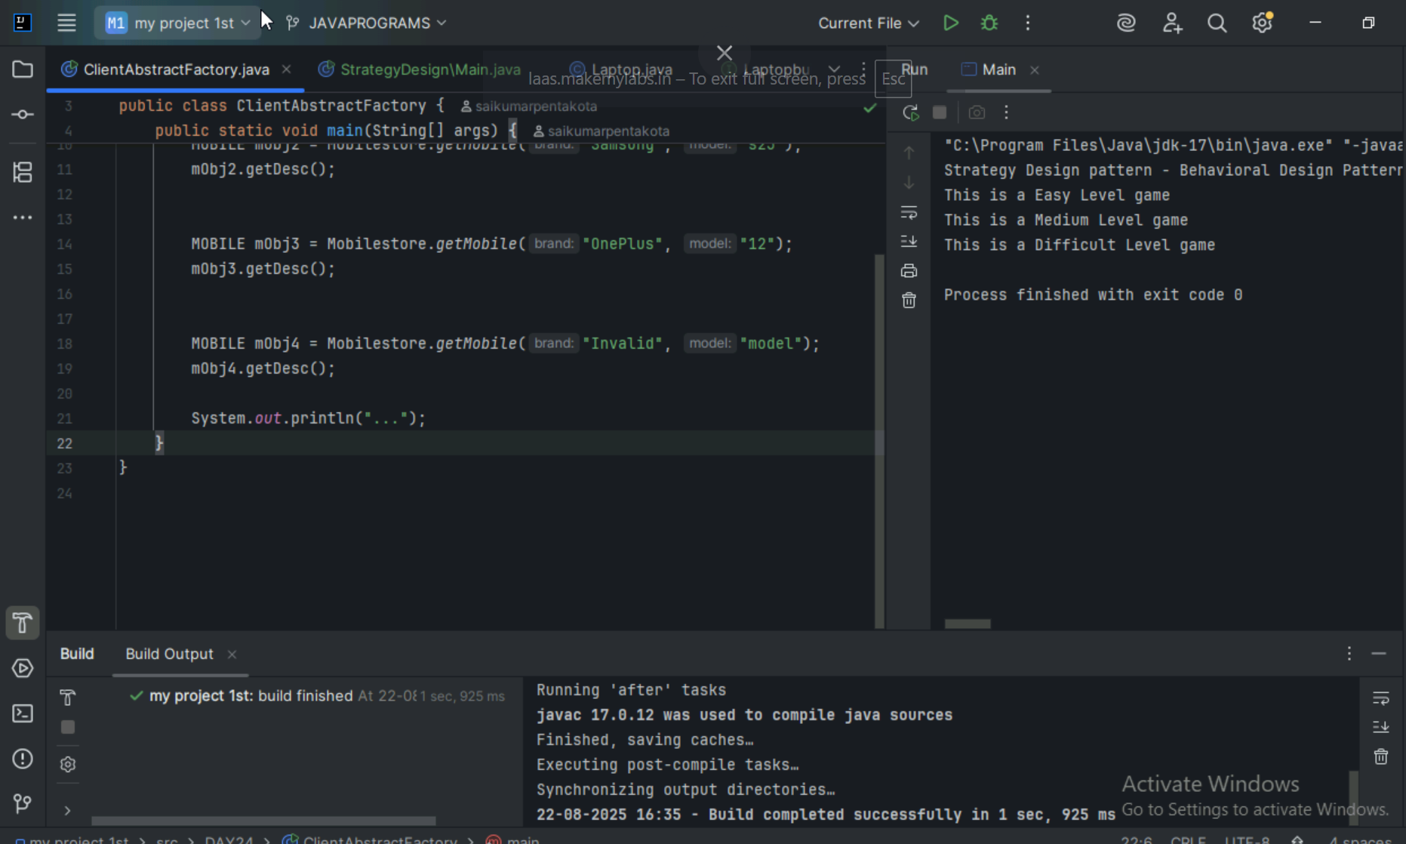

TASK1

What do you know about Design Work Flow

A design workflow is a structured, often visual plan of sequential tasks, activities, and decisions required to complete a design project, from initial ideation to final output. It clarifies processes, improves communication and collaboration, reduces errors, and increases overall efficiency by providing a clear order of operations, defining roles, and enabling teams to meet project goals effectively

What do you know Persistent objects:

Persistent objects are data or objects that retain their state even after the program or process that created them has ended, allowing them to be retrieved across sessions and users. Diagrammatic representations of persistent objects include persistence diagrams, which show the birth and death of features in topological data analysis, and various vector or landscape-based representations derived from these diagrams to enable mathematical operations like distance calculations.

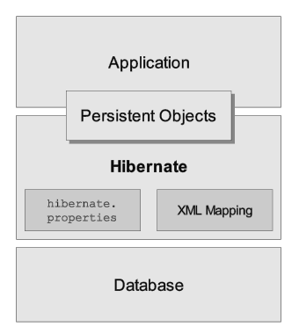

Which of the following components is not typically part of the Command pattern?

a) Invoker

b) Receiver

c) Abstract Factory

d) Command (interface/abstract class)

What role does the Invoker play in the Command pattern?

a) It knows how to perform the operations associated with a request.

b) It encapsulates the request as an object.

c) It asks the command to carry out the request.

d) It defines the interface for executing an operation.

A key benefit of using the Command pattern is its ability to support:

a) Lazy initialization

b) Undo/Redo functionality

c) Singleton instance creation

d) Compile-time polymorphism

In the Strategy pattern, what role does the "Context" play?

A. It defines the interface for the algorithms.

B. It implements a specific algorithm.

C. It maintains a reference to a Strategy object and delegates the task to it.

D. It creates the Concrete Strategy objects.

In which of the following mechanisms, types of all variables and expressions are fixed at compilation time.

a) Strong Typing

b) Weak Typing

c) Static Binding/ early binding

d) Dynamic Binding/ late binding

In which pattern does a class represent the functionality of another class, providing a simplified interface to a complex subsystem?

a) Decorator Pattern

b) Facade Pattern

c) Proxy Pattern

d) Composite Pattern

Which of the following statements about Persistence is correct?

a) It is the enforcement of the class of an object, such that objects of different types may not be interchanged, or at the most they may be interchanged only in very restricted ways.

b) It is the property of an object through which its existence transcends time and/or space.

c) It is the property that distinguishes an active object from one that is not active.

d) All of the mentioned

What is that concept in type theory in which a single name may denote objects of many different classes that are related by some common super class referred to ______

a) Monomorphism

b) Type Checking

c) Polymorphism

d) Generalization

Which of the following patterns is used to create a single instance of a class and provide a global point of access to it?

a) Factory Pattern

b) Singleton Pattern

c) Builder Pattern

d) Prototype Pattern

The Adapter pattern is a type of ______ pattern.

a) Creational

b) Structural

c) Behavioral

d) Concurrency

Which design pattern defines a one-to-many dependency between objects so that when one object changes state, all its dependents are notified and updated automatically?

a) Strategy Pattern

b) Command Pattern

c) Observer Pattern

d) Mediator Pattern

The Model-View-Controller (MVC) is an example of a ______ pattern.

a) Creational

b) Structural

c) Behavioral

d) Architectural

TASK16

